Atitit 著名勋章设计

[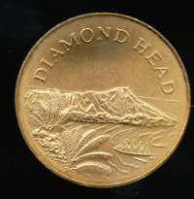](http://qzs.qq.com/qzone/photo/v7/page/photo.html?init=photo.v7/module/photoList2/javascript:void(0))

mBOr-pKmjevkCkznnsSp2gA

[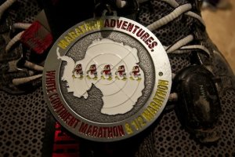](http://qzs.qq.com/qzone/photo/v7/page/photo.html?init=photo.v7/module/photoList2/javascript:void(0))

medal

[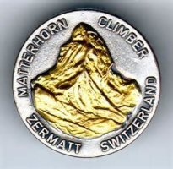](http://qzs.qq.com/qzone/photo/v7/page/photo.html?init=photo.v7/module/photoList2/javascript:void(0))

th (1)

[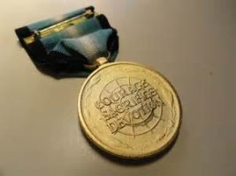](http://qzs.qq.com/qzone/photo/v7/page/photo.html?init=photo.v7/module/photoList2/javascript:void(0))

th